Advanced Artificial Intelligence - Casual Inference II

**Adjust Formula**

Intervening on X is equivalent to conditioning on it in the manipulated model

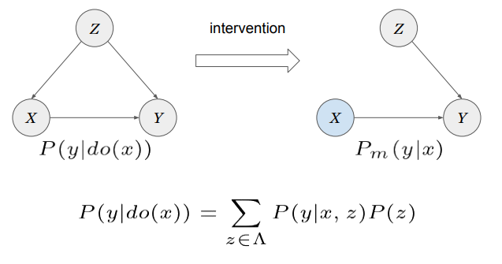

**Unobserved Confounders**

The variable Z, called also confounder, might not always be observable (called a confounder because it is connected to the treatment X and the outcome Y).

E.g. maybe we don’t know the gender Z of the patients in the Simpson’s paradox example

In this case we wouldn’t be able to “block” the path X🡨 Z🡪Y, and therefore there is a spurious (of an offspring, fake) correlation between X and Y influencing the casual effect.

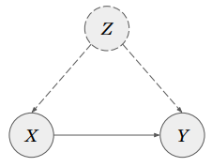

**Adjustment with Unobserved Confounders**

There might be cases though where other non-parent variables are available.

E.g. maybe the gender Z is not available, but we know the weight W through which the recovery Y is affected.

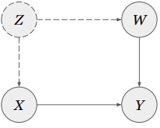

The question is whether we can take advantage of these variables to derive an expression for P(y | do(x)).

**Backdoor Path**

To answer this question we need to introduce the concept of “backdoor” path, which is any path linking X and Y with an arrow entering X (therefore including its parents). A path can be “blocked” by conditioning on its chains/forks.

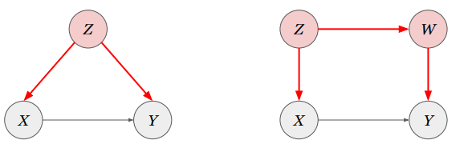 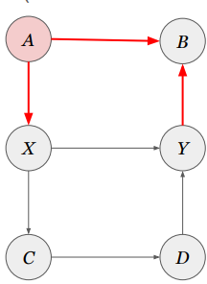

**Backdoor Criteria**

A set S of variables satisfies the backdoor criterion if

* 1( it blocks every backdoor path between X and Y)
* 2 it doesn’t contain any descendant of X.

The following are valid sets satisfying the criterion:

{ } because B is a collider

{A}

The following are not valid sets instead:

{B}, {A, B} B is a descendant of X

{C}, {D}, {C, D} they are descendants of X

What is the backdoor Criteria in this example?

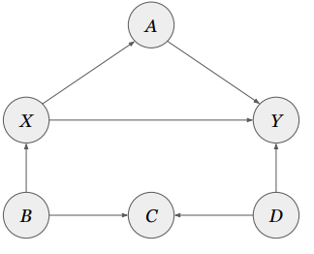

Valid sets satisfying the backdoor criterion are:

{ }, {B}, {D}, {B, D}, {B, C}, {C, D}, and {B, C, D}

**Adjustment Formula with Backdoor Criteria**

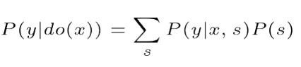

Where s are all the possible values of the variables in **S**

Note this is the same adjustment formula already seen last week, but where the adjustment is done for any valid set satisfying the backdoor criterion, not just the parents of X.

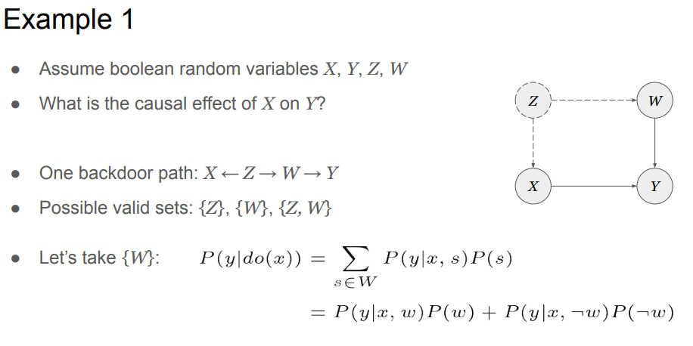

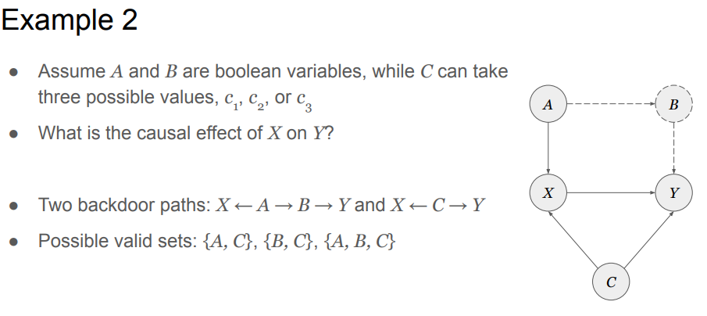

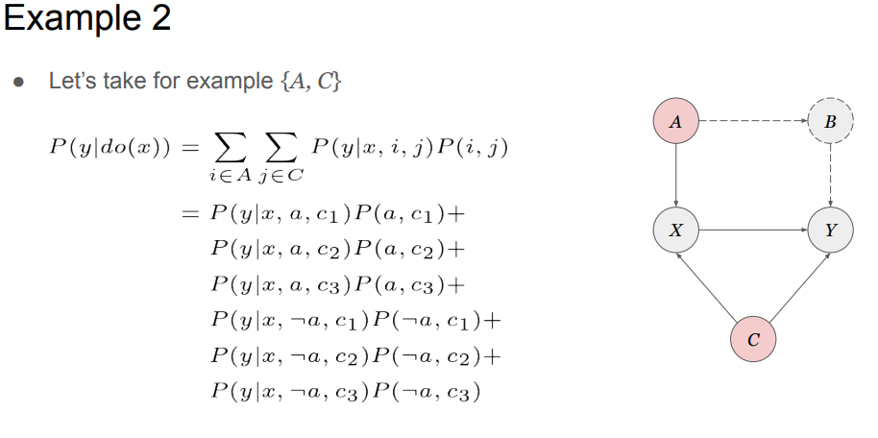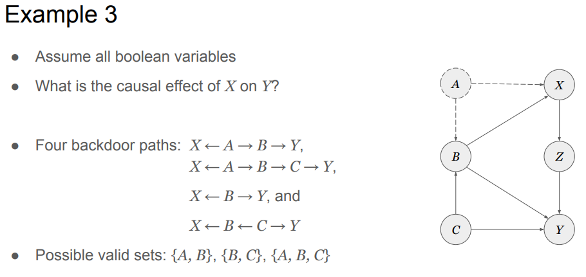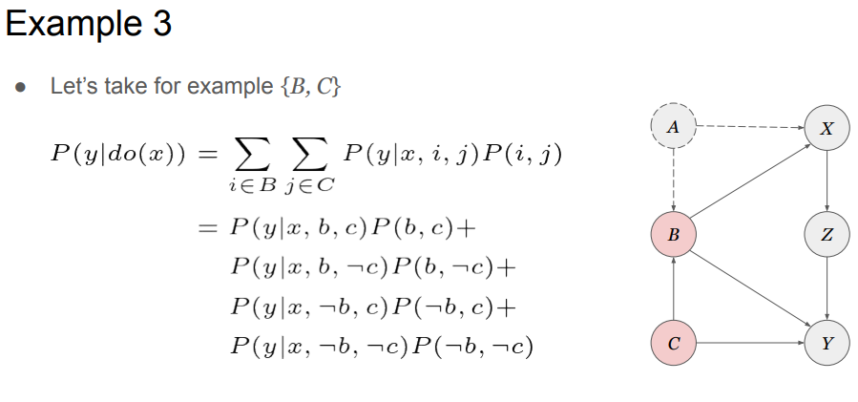

**Unobserved Confounders**

Sometime none of the confounders is observable, but there might be other intermediate variables bbetween the treatment X and the outcome Y

For example, a casual model of smoking --> cancer could be the following:

X = smoking

Z = tar deposit in the lungs

Y = cancer

U = “smoking gene” (unknown)

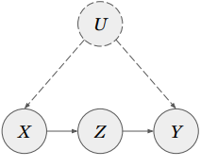

**Unobvserved Confounders**

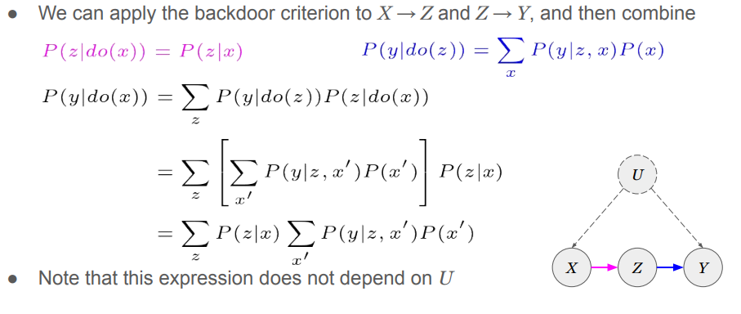

**Unobserved Confounders**

Assuming all the variables are boolean, we can calculate the causal effect of smoking on lung cancer by observing the presence of tar deposit, even without knowing if there are other confounders (e.g. smoking gene).

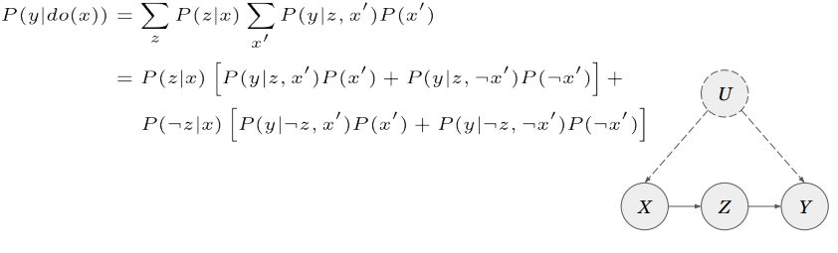

**Front-Door Adjustment**

A set S of variables satisfies the front-door criterion if 1) it blocks every directed path between X and Y, 2) there are no backdoor paths between X and S, and 3) all the backdoor paths from S to Y are blocked by X.

If S satisfies the front-door criterion, then the following formula can be used to compute the causal effect of X on Y (front-door adjustment).

**Front-Door Paths: Examples**

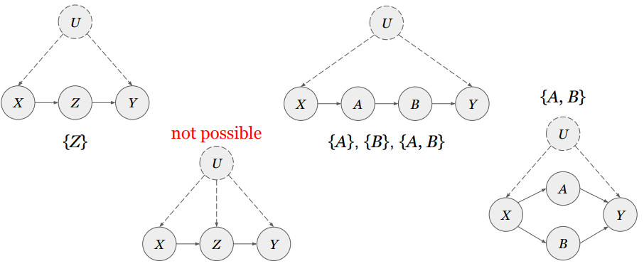

**Reading and Resources**

Pearl, Glymour & Jewell “Causal Inference in Statistics -- A Primer”

* Ch 3 - Sec 3.3, 3.4

Online resources

* Causality101 (examples from the book) -- <https://causality101.net/>

Software libraries -

* CausalGraphicalModels -- <https://github.com/ijmbarr/causalgraphicalmodels>
* DoWhy -- <https://github.com/microsoft/dowhy>
* Causal Inference in Python -- <https://causalinferenceinpython.org/>
* CausalML -- <https://github.com/uber/causalml>

**MSc Project Opportunities**

● Part of a new EU project -- https://darko-project.eu/ ○ robot navigation in human environments ○ tools for causal inference from robot sensor data

● Requirements: ○ Good mathematical and programming skills ○ Robotics experience is a bonus, but not necessary

● Get in touch if interested!